***Ademy***

**Specification**

**Requirements**

**Documentation**

Table of Contents

1 Vision………………………………………………………………………………………………………………………………3

2 In Scope…………………………………………………………………………………………………………………………..3

3 Out of Scope……………………………………………………………………………………………………………………3

4 Key Features……………………………………………………………………………………………………………………4

5 Personas…………………………………………………………………………...................................................5

5.1 Student Persona…………………………………………………………...........................................5

5.2 Administrator Persona…………………………………………………………………………………………6

6 Scenarios………………………………………………………………………...………………………………………………7

6.1 Student Scenario………………………………………………………..……………………………………….7

6.2 Administrator Scenario……………………………………………………………………………………….8

7 Site Map Student…………………………………………………………………............................................10

8 Wireframes Student………………………………………………………………..........................................11

9 Functional Requirement Student…………………………………………………...................................21

10 Site Map Administrator………………………………………………………………………………………………..21

11 Wireframes Administrator……………………………………………………………………………………….…..24

12 Function Requirements Administrator………………………………………………………………….………33

13 Non-Functional Requirements………………………………………………………………………………………33

14 Technologies Utilized……………………………………………………………………………………………………36

15 System Architecture……………………………………………………………….........................................36

16 Physical Architecture…………………………………………………………………………………………………….36

17 Class Design………………………………………………………………………..............................................36

**1 Vision**

Sometimes you lose motivation, life gets hard and it can break you down. Maybe all you need is a gentle push to build yourself back up. Our vision is to give each student at Middle College High School that nudge with TrackAdemy, their own Personal Education Tracker, or P.E.T. Whether from P.E.T.’s rewarding interface with their own customizable pet based on their attending hours, or from P.E.T.’s access to visually appealing and informative graphs, you’ll find P.E.T. inspiring a sense of responsibility and elevating self-worth, because wherever they go, so will their P.E.T., always cheering them on.

**2 In Scope**

**IS 2.1** TrackAdemy will track the students’ community hours using a single terminal located in the classroom where they will log in when they arrive and log out when they leave by clicking on their picture each time.

**IS 2.2** TrackAdemy will automatically log out students at the end of the day in case they forget to log out.

**IS 2.3** Administrators will have full access of student profiles to ensure correctness of statistics. They will have tools to manipulate data or change results as necessary.

**IS 2.4** TrackAdemy will provide detailed reports to the administrator of each students’ attendance including total community hours, days of the week attended along with hours of each day attended.

**IS 2.5** TrackAdemy will provide the administrator with an easily sharable report of student statistics.

**IS 2.6** At the end of the year a student’s information will be rolled over and archived into a saved document.

**3 Out of Scope**

**OS 3.1** Students will not have private access to the terminal page as only one in class terminal accessed by the admin will feature that capability.

**OS 3.2** Database of students’ personal information will not be accessed; therefore, security architecture will not be addressed.

**OS 3.3** Reports of students’ academics will not be included in student profile report. This is an attendance tracking system only.

**OS 3.4** Students will not have access to their data to prevent the student from changing or manipulating their community hours.

**OS 3.5** The system will not be connected to any outside network therefore, network architecture will not be implemented.

**OS 3.6** The web application will not give the student the ability to login or logout of the community hours tracking system.

**OS 3.7** The web application will not be offered to anyone other than Middle College High School students the administrator adds to the system.

**OS 3.8** The web application will not be accessible to the student after they have completed their time at Middle College High School.

**4 Key Features**

TrackAdemy is a system encompassing many features benefitting the administrator and student, including an attendance tracker, report generator and web application. TrackAdemy will not only self-track student attendance but also encourage them to attend.

|  |  |  |
| --- | --- | --- |
| ID | Feature | Description |
| FR1 | TrackAdemy  (Attendance Tracking System) | To help the teachers and administrators of Middle College High School know who goes to class and how long they stay in class. The system will keep track of students as they sign in to the class room and sign out. Students will find their name sign in when they arrive and find their name and sign out when they leave. |
| FR2 | Reports Feature | To help boost students’ attendance will receive separate reports detailing student attendance. Student reports will more be based on positive reinforcement. Admin reports will include all data needed. |
| FR3 | Personal Education Tracker  (P.E.T Mobile App) | Gamified web interface that allows students to create a pet and earn rewards for that pet based on their attendance hours. Students will have reports of rewards they’ve earned as well as their positive attendance statistics. |

**5 Personas**

##### **5.1 Student Persona**



Alex was a great student before, however, because of a stressful family situation he started running with the wrong crowd, eventually getting himself arrested and sentenced. Alex got out of jail after one year and he took sometimes off from school because he was not emotionally ready to go back and studying. He is now 21-years-old and no longer eligible to attend Garfield High. Alex’s probation officer sees the potential in Alex and has encouraged Alex to enroll in Middle College High School. Alex is smart enough to understand the materials but often arrives to school late due to lack of enthusiasm and tends to leave early to hang with his buddies. He knows he needs passing grades to receive his diploma yet tends to get discouraged because all his life his family has told him he will never amount to anything. Always being negatively reinforced has discouraged Alex from pushing himself. Alex tends to get along with his peers in school but sometimes feels like he doesn’t belong to the community. There is one-time Alex always thinks back to when he was sick with the flu, didn’t show up to school for a couple days in row and one of his classmates asked him the next day “is everything ok because, dude, you’re normally late and normally leave early but you’ve never missed that many days”. When Francine inquired about Alex, it occurred to him that he couldn’t remember the last time anyone cared about where he was (aside from his parole officer and the teachers).

##### **5.2 Administrator Persona**



Genie is a 45-year-old woman who was never able to have kids of her own but always wanted them. She spent most of her late 30’s housing kids in the foster system. She needed to stop, although it wasn't easy, because she adopted one of the kids she fostered, and it would be too difficult to house a foster kid as well as her own. She loved feeling like she was making a difference in the lives of the next generation and seeing breakthroughs in kids whom at one time felt lost and alone. Rather than give up completely on her greatest passion in life, she decided to get a teacher's license and began teaching at a new alternative school for foster kids or those who had nowhere else to go. This is where Genie currently works, and she loves it. She never thought anything could fulfill her as much as fostering, but she thought wrong. The only difficulty is getting the students to class - on time, all day, every day. She understands why a lot of the students miss class, but also wants to provide structure in students' lives which are a bit more chaotic than anyone could handle, much less a kid. She doesn't want to scold or force her students to come to class because she doesn't want school to have any more of a negative connotation than it already does; rather she wants to change the way these students think about school to where they look forward to it so much that they are there pretty much every day and are well engaged with materials as well as each other. Her mother used to say something about how going to church rarely ever about God but is always about the sense of community, and she finally understands that now. Genie wants class to become her students' church. Because she teaches in a school, she needs to keep attendance, but doesn't want the attendance tracking to discourage her students who have a difficulty showing up to class as it is. She knows that she would like to keep track of the time spent in class but doesn't know much else other than she wants her students to be the ones to mark themselves present, so they feel more of a sense of ownership over their education. The fact that she would have a lot less paperwork also wouldn’t hurt so she’d have more time to spend with her adopted son as well as give even more of herself in class. However, Genie has some reservations about trying to implement a new attendance taking system because although she knows how to Google things, she definitely does not consider herself a computer whiz and would rather stick to the current system over having to be ‘trained’ on how to use a new one.

**6 Scenarios**

**6.1 Student Scenario**

**Login / Logout Kiosk:**

It’s 8:55 and Alex is running to the campus. He woke up late because last night was the birthday of Laden, his childhood friend who just turned 21. He arrives to class exhausted and with barely any time to spare. When he gets there a few students are waiting in line to talk with the teacher (Mr. Taylor). Mr. Taylor asks him to turn around and check in on the computer on the side desk. A small space has been dedicated in the classroom that allows for a speedy check in to Middle College High School. Alex moves the mouse and the screen appears. Mr. Taylor already logged in to his account and the “TrackAdemy” webpage has all the name of students. He looks up to see who has yet to arrive, and notices quickly that he is the last of his class to show up. Rather than make a scene and disrupt the class by staggering in and interrupting Mr. Taylor, he simply clicks on the little check box next to his profile picture and heads to his seat. It’s nice how simple and easy the new “TrackAdemy” system is. Also, yesterday he received an email about downloading the new app on the phone, so they can check-in by their cellphones but since it’s optional, he hasn't get this chance to do it so. It seems so simple to figure out this application and doesn’t call for approval of presence. The application tracks the ins-and-outs every day and archive the check ins. It says hi to him with a pop-up message and based on the recorded check ins lets him know that he’s done pretty good getting to class for the third day in a row. He likes the way that this webpage is quick and responsive and easy to get around. He also doesn’t always communicate well with other so he’s happy to be able to just get in get to his seat without having to explain himself on the mornings he’s late. Now, all is good, and Alex is waiting for the class to be started at 9. Alex is checking the TrackAdemy app descriptions in his email, while waiting for class to be started. The good thing is he doesn’t need to stay in line for checking in. The app descriptions seems pretty fun because it provides different ‘avatars’ and he can purchase or win, also some other things like a cool Lamborghini. As much as he attends the class he can gain points to play better in this game. He can also can customize what he can buy based on their prices and the coins he achieved.

Later when Alex wants to meet up for lunch with Laden again. He downloaded the application on his cellphone during the short break and now he can check out on his phone if he wants. For checking out, he just needs to unclick the clicked box next to his profile picture. He even gets a print out to see how well he’s been doing with attendance. Being able to see the hours he puts in daily is nice to see. It shows that every week he gets closer to his goal of graduating and moving up in the world one day.

App:

While lying in bed that night, Alex remembers the new game for school and downloads TrackAdemy. Alex starts up the app and he is prompted to log in with the username and password he uses to log in to the website. A fox named Major walks to the center of the screen and lets Alex know that he is his “P.E.T.” which apparently stands for Personal Education Tracker, but to think of him just like anyone else. Major then says that he wants to be a part-time neurosurgeon and a part-time world renowned exotic fur trader and shows Alex a picture of what that could look like. Major tells Alex that he has already earned 120 coins for staying in school that entire day, and that he’d get a streak-bonus if he was able to stay the entire time tomorrow. Alex is also excited to learn that he can buy the items Major was wearing with his coins and that he’d get bonus coins for getting to class early and/or staying late. He feels like that could be pretty doable since he heard some kids in his class earlier that day talking about meeting at 8:45 the next morning to trade items that they were able to purchase already. Alex feels like it could be pretty cool getting to know some of the guys better as well since they have only ever really talked in passing. Major then asks Alex how long it takes to get ready in the morning, how many alarms it takes to wake up, and how much time it usually takes to get to class. Major replies saying that Alex should set 3 alarms for 7:00, 7:30, and 8:00 am in order to get to class with on time. Alex notices that it those alarms would probably get him to class about 10 minutes early. Major then yawns and says he’s going to go to bed, Alex should as well, and that he hopes to see Alex tomorrow. Alex closes the TrackAdemy game and begins feeling his addiction to the game already starting to creep up. Alex sets his alarms for the next day and goes to sleep ready to earn some coins.

##### **6.2 Administrator Scenarios**

Local Terminal:

Genie arrives to class at 8:50 am excited, and a little nervous, to try out this way of trying taking attendance. She got to class a little bit later than she hoped to that day, so she won’t have much time to figure out the new system if it’s confusing. She was told that it would be change the way she thought of attendance and would motivate the students to come to class by making attendance a currency for the game app which her students will be able to use on their phones outside of class. She has noticed that kids these days spend a colossal amount of time on their phones, so she thinks this game app will be the perfect intersection of school and fun. Genie puts her bag down on her chair at the front of the classroom and heads to toward the computer next to the door. Genie powers on the computer and double clicks the TrackAdemy icon. A window pops up after about 3 seconds and she sees a screen that has pictures of all the students each with an animated sleeping kitten in a little picture-in-picture window. The text at the top of the screen says: “Students! Mark yourself present by clicking your picture and receive a little gift from me, to you! ~ Love, Ms. Genie”. Genie turns and heads back to her desk relieved that the attendance program basically runs itself. As she gets back to her desk she hears someone walk into the class, and when she turns around she’s shocked to see Luke who hasn’t been in class for a week or so bending over the computer. Genie says‘Good morning’ as Luke straightens up and begins playing with his phone. She notices Luke seems completely entranced by whatever is on his phone screen, so she asks what he’s doing. To her surprise Luke tells her that he got the email about the attendance app that he was supposed to download, and it turned out to be pretty fun. Luke tells her that there’s all whole bunch of different ‘avatars’ that he can purchase or win, as well as items for them like pom-poms, or even things like a Lamborghini that he can buy and give to them just by coming to class. Luke shows Genie his phone screen and gestures to a notification saying that he just won a new avatar and 50 coins for getting to class a little early. He then turns his screen back around and to decide what customization he wants to buy. Genie is ecstatic because of how immediate the results of having a phone app had. When class starts she has a mostly full classroom, which is more than she’s ever had at one time this entire year. Genie instructs the students to put their phones away and begins class with renewed fervor because her classroom is finally starting to feel like a class.

Report:

It has now been a couple of weeks since the launch of her new attendance system, and Genie is noticing a significant change how filled out her classes have gotten. As Genie gets back home after a day of school and a trip to the grocery store, she remembers that she wanted to check on Luke’s attendance report because she feels like she’s seen him pretty much every day and is curious as to how great he’s been doing. She decides to check on his attendance statistics before putting the groceries away, so she puts her things down in the kitchen and walks to her laptop. She opens the TrackAdemy website and logs in. Genie then sees a drop-down menu that reads “Select a Student". Genie clicks on the menu which shows a list of students' names in first-name alphabetical order appears with their picture just to the right of the name. Genie clicks on Luke which then shows his statistics with the options: this week, last week, last month, last three months, last year, and all time. Genie knows that Luke’s been coming to class often over the past couple of weeks, so she chooses to see statistics over the past month. Not to her surprise, the graph she sees shows that Luke has had a significant improvement in both the number of days as well as the number of hours he’s been in class; she is more excited than ever to be able to show Luke how well he’s been doing and thinks he’ll feel the same. Delighted by the fact, Genie closes her laptop and goes back to put her groceries away.

**7 Site Map Student**

**SMS 7.1 Student Website**

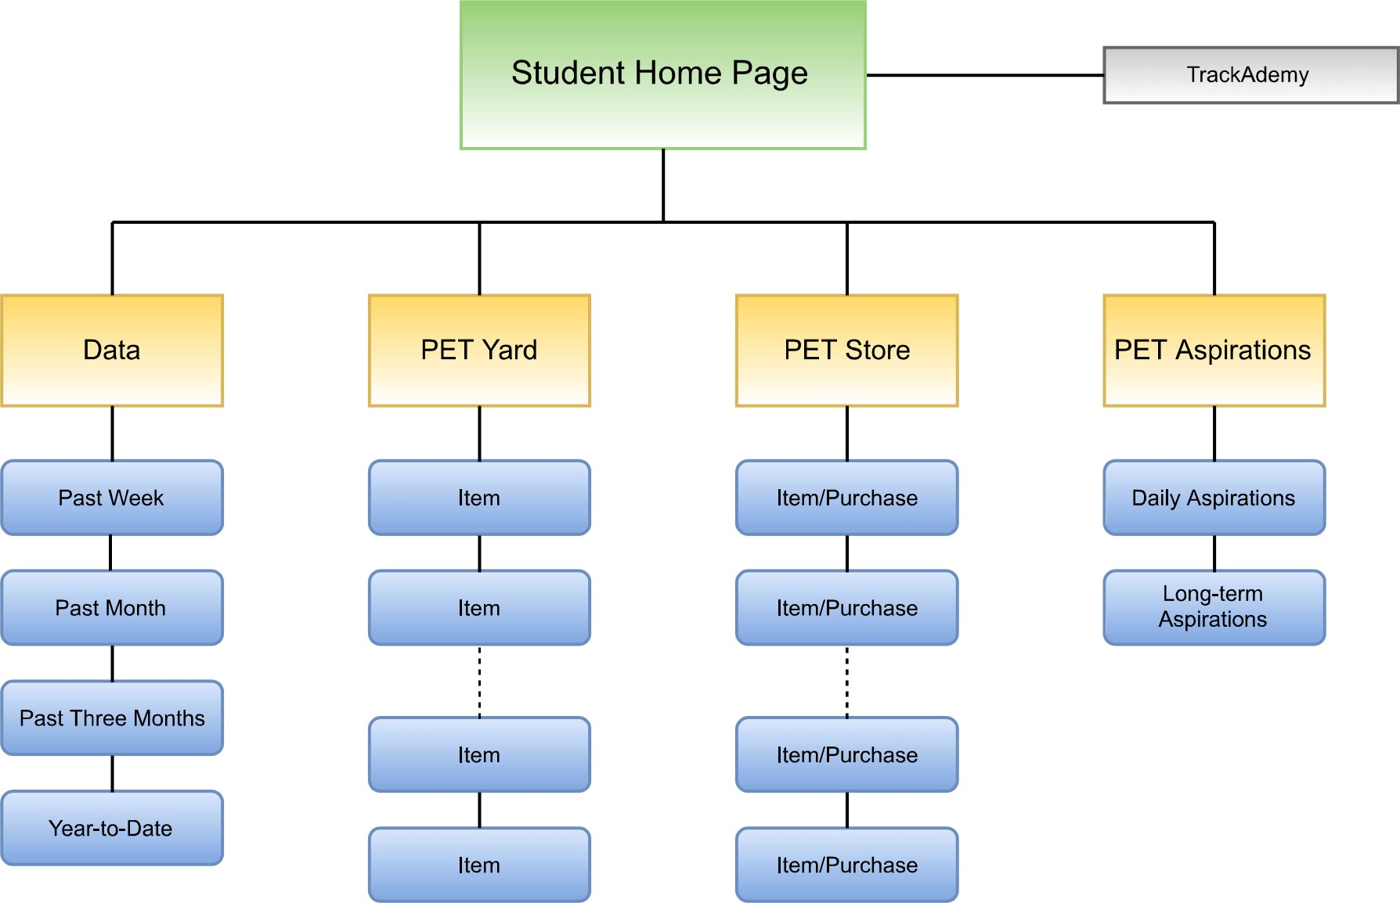

**8 Wireframes Student**

**FRS 8.1 Student Remote Login**



This is the login page for the students, fairly standard, with the image being the TrackAdemy logo.

**FRS 8.2 Student Home Page**

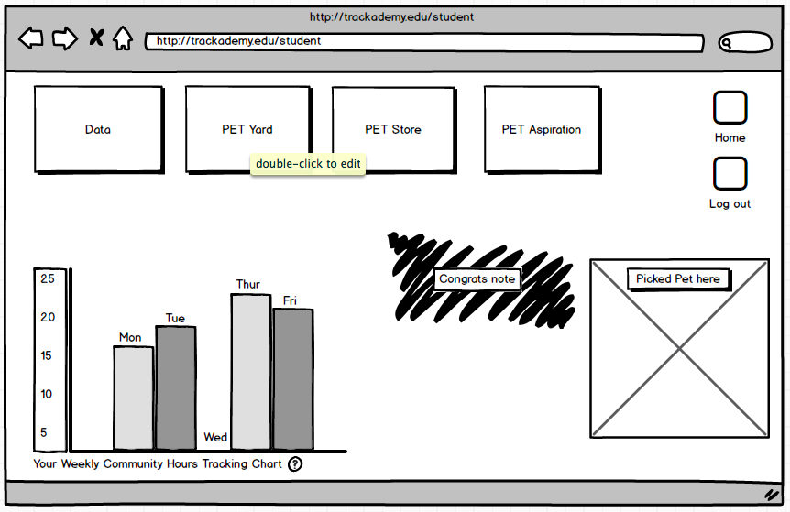

This page is the main page that will be the first thing the student sees upon logging in. This is meant largely as a hub with extra attention drawn to the other pages available, and a quick note from the pet about how well the student is doing. The chart offers quick at-a-glance data for the student in case that’s all they want to see.

**FRS 8.3 Student Data Page**

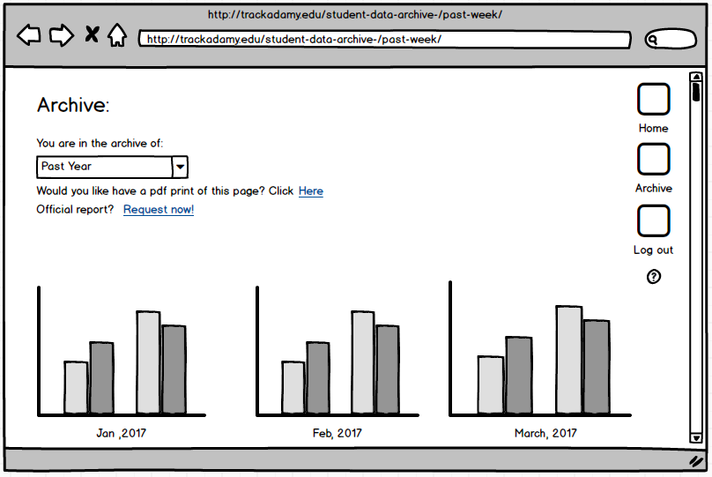

This page allows the students to see the data from years past during their enrollment in the system. Archival data for the student will likely consist of few options, including past year. They will be able to scroll through the months, showing each month with various metrics.

**FRS 8.4 Student Pet Yard**

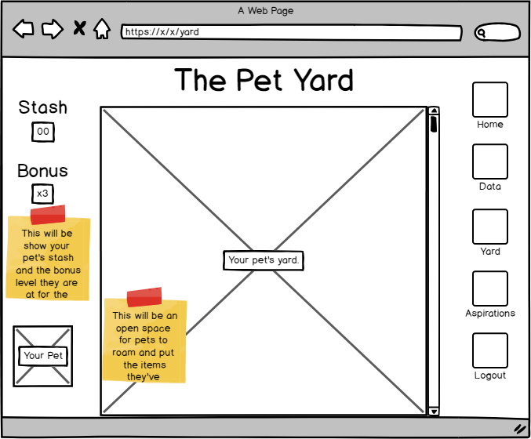

The focus for this page is to showcase the upgrades purchased or earned. The yard may feature many cosmetic upgrades and the pet itself may roam the yard showing its custom appearance.

**FRS 8.5 Student Pet Store**

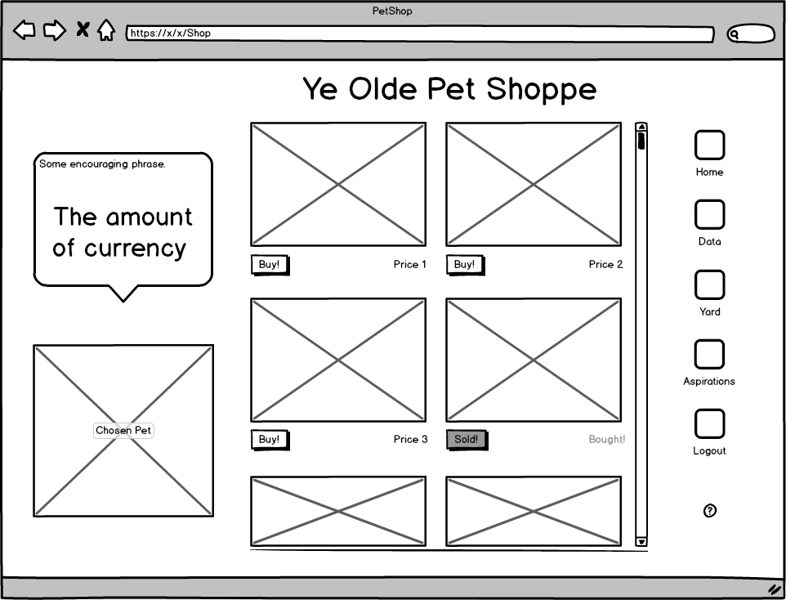

The Shop will show the Pet telling the student how much currency they have predominantly, with a phrase that might be encouraging to the shop system, such as “I’ve always wanted that Tophat!”. Optionally, the phrase can be something more generic, like, “Buy something to upgrade my yard or equip me with!”

**FRS 8.6 Student Pet Aspirations**

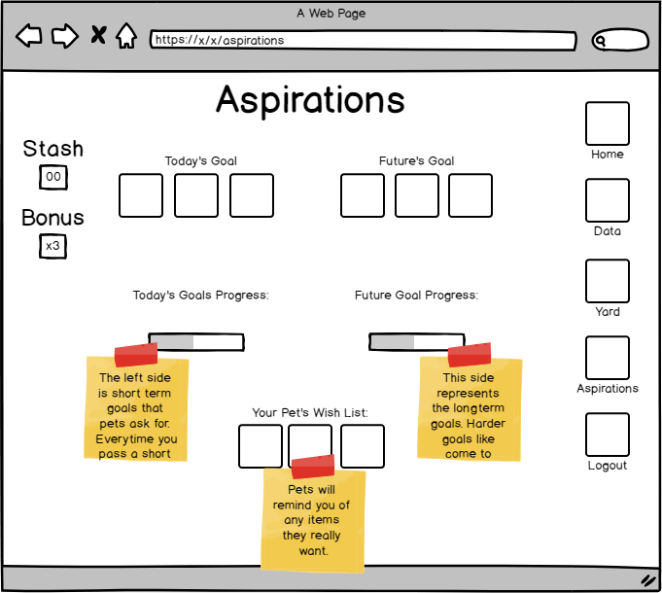

This page is largely to help students see some tangible goals they can set if they wish. It also doubles as a reason to visit the shop to spend the stash, with reminders of items they might be able to or are close to being able to purchase.

**FRS 8.7 Student Logout Page**

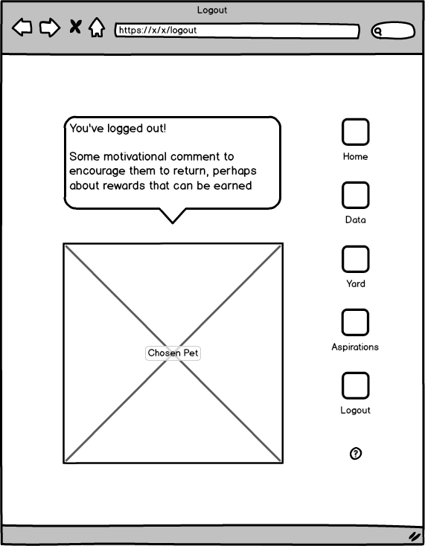

This logout screen may optionally be included to further motivation, highlighting what a student could achieve on a subsequent login or highlighting how close a student is to a goal or ability to buy a reward from the Shop.

**FRS 8.8 Student Help Page**

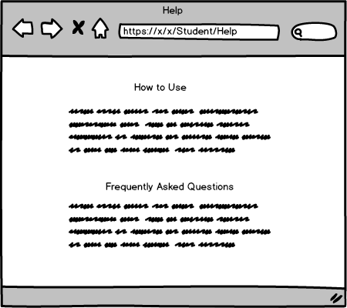

This is the student help page to help them use the site with explanations of features.

**FRS 8.9 Home Page**

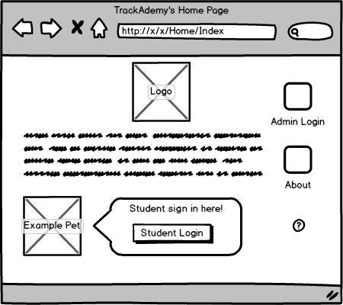

This is the home page for traffic that goes to the URL, everyone will come here and then choose to sign in if they are either a student or admin. The text will state a little bit about what the site is.

**FRS 8.10 About Page**

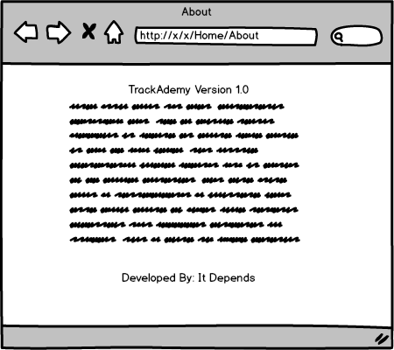

This page shows the about information for the website.

**9 Functional Requirements Student**

**FRS 9.1** **Login/Logoff**

Students shall log into and out of the system.

**FRS 9.2** **Automatic Logout**

The system shall automatically logout a student at 3:55pm to ensure community hours are no longer being accumulated if a student forgets to logout prior to leaving.

**10 Site Map Administrator**

**SMA 10.1 Administrator Website**

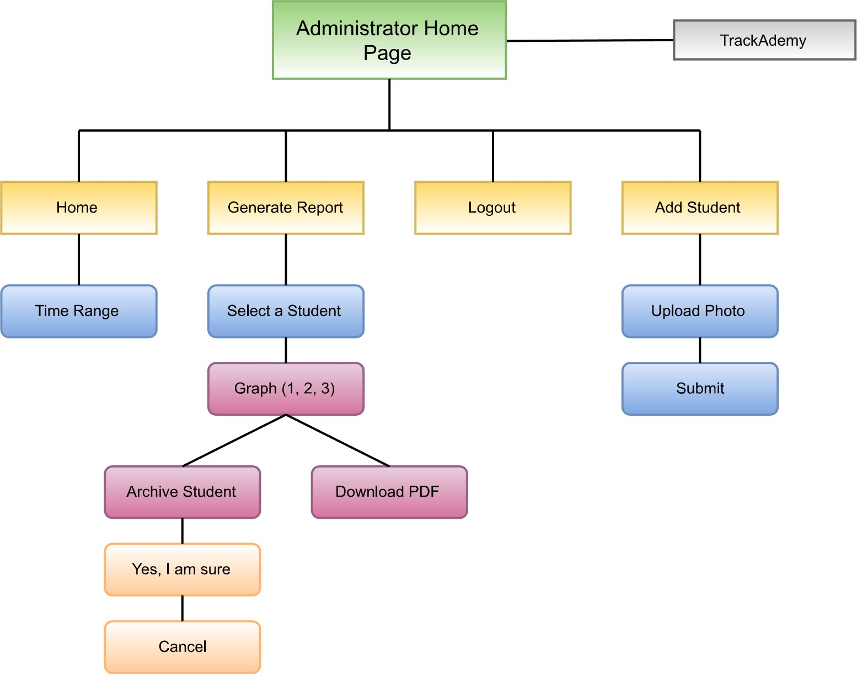

**SMA 10.2 Kiosk Login**

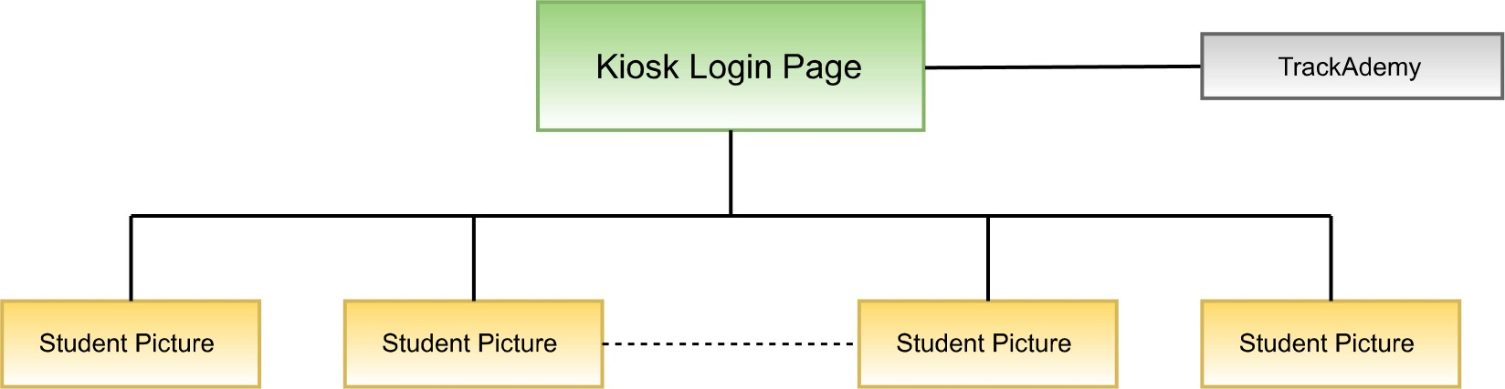

**SMA 10.3 TrackAdemy Main Page**

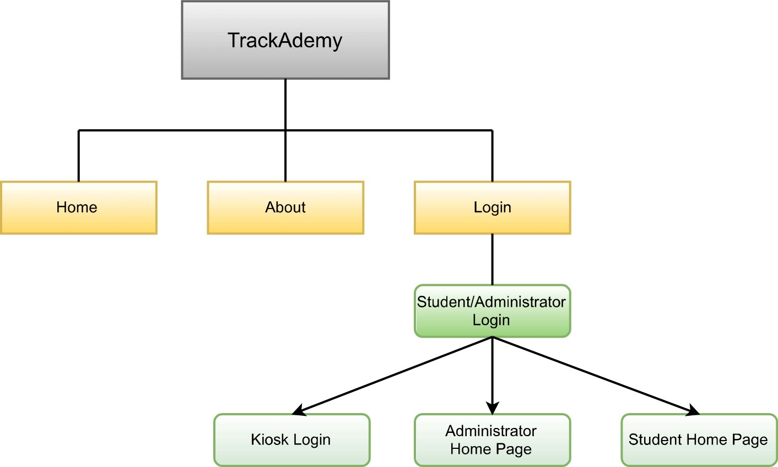

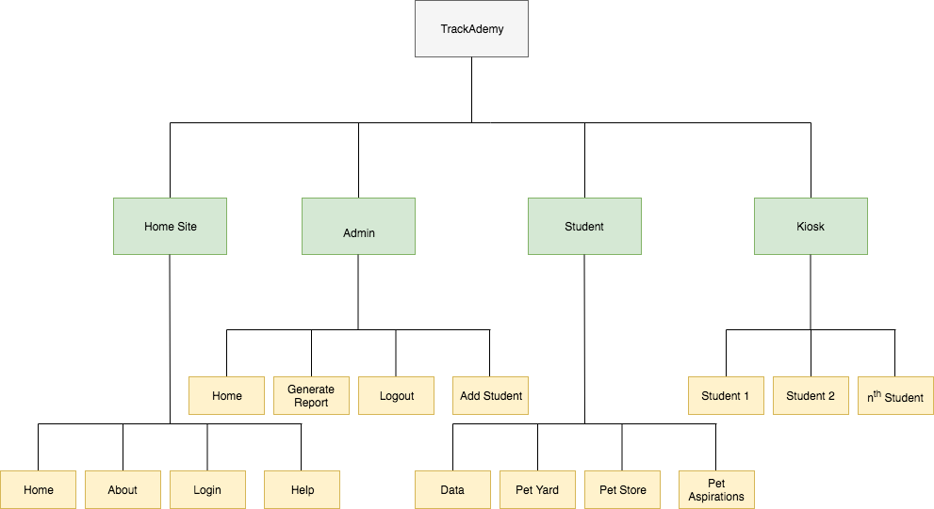

**11 Wireframes Administrator**

**WFA 11.1 Kiosk Attendance Tracker**

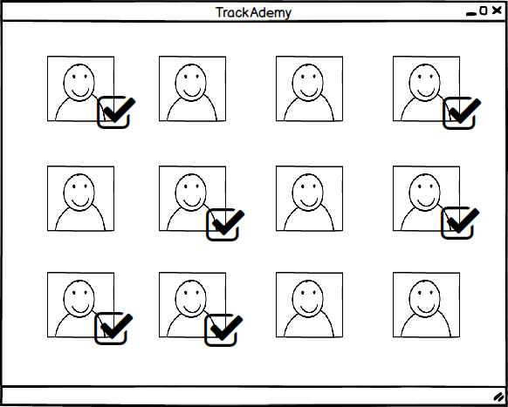

Provides the interface for students to mark themselves present by clicking on their picture, and then marking when they leave school for the day by clicking. A checkmark appears when the student marks themselves present.

**WFA 11.2** **Administrator Remote Login**



Login screen from the trackademy.edu home site. Using credentials that are specific to each individual administrator they login and can access reports and student profiles. Also has links for forgot password and username.

**WFA 11.3** **Administrator Home Page**



Home screen once the administrator logs in.Simple diagram showing students attendance streak for that week.

**WFA 11.4** **Administrator Report Generator**



What the administrator sees after clicking “Generate Report” (minus the sticky note, which was added for clarity in wireframe).

**WFA 11.5** **Administrator Report Generator: Showing Student**



The report the administrator sees after entering a student name in “Generate Report”. Allows administrators can change the time frames on the graph to generate reports from the day, the week, the month, the semester and the entire school year.

**WFA 11.6** **Administrator Report Generator: Showing Student -> Archive Window**



What the administrator will see after clicking archive student. Once the school year is over the admin can archive the data from the repots for each year. This is so they can go back and access data from the previous year.

**WFA 11.7** **Administrator Report Generator: Post-Archive**



What the administrator will see once they confirm that they would like to archive a student.

**WFA 11.8** **Administrator Add Student**



The screen the administrator will see after clicking “Add Student”. Allows them to add a student to the roster.

**WFA 11.9** **Administrator Help**

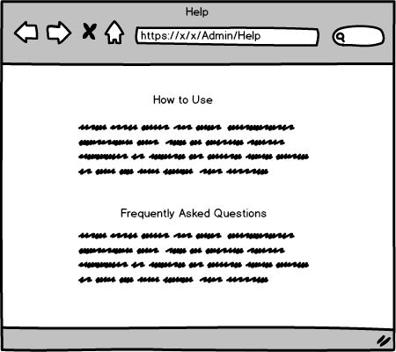

This page will guide the admin through how to use the site in a simplified manner.

**12 Functional Requirements Administrator**

**FRA 12.1** **Login/Logoff**

The administrator shall be able to log in and out of the system.

**FRA 12.2** **Reports Generation**

Reports shall be generated for all students enrolled in the school. These reports shall include records of attendance tracked by community hours.

**FRA 12.3** **Adjusting Student Community Hours**

The administrator shall be able to adjust the students’ community hours on an as-needed basis. This will include how many hours they attended on a specified day.

**FRA 12.4** **Archive/Rollover**

The administrator shall have to do nothing to archive/rollover student information. The system shall archive/rollover student information automatically, keeping the information for 7 years. After 7 years, the information shall automatically be deleted from the system.

**FRA 12.5 Calendar Maintenance**

The admin shall be able to adjust the schedule for "professional days" and other aberrations in the school calendar.

**FRA 12.6 Modification of Students in the System**

The administrator shall have the ability to modify (add and delete) students to the system.

**13 Non-Functional Requirements**

**NFR 13.1 Data Retention**

**NFR13.1.1** Attendance records for each individual student shall be saved on their profiles for the remainder of the school year.

**NFR 13.1.2** At the end of the school year students’ records shall be archived to a separate database.

**NFR 13.1.3** A student’s information shall be saved until they graduate or until they leave the program.

**NFR 13.1.4** A student’s profile shall require only basic identifiable conventions such as name and password for log in purposes. No other sensitive data shall be stored.

**NFR 13.1.5** All information shall be retained on a database in Microsoft Azure.

**NFR 13.2 Deployment Architecture**

**NFR 13.2.1** Students shall have access to check in to school on one terminal located in the class room.

**NFR 13.2.2** TrackAdemy shall be deployed using a website-based application.

**NFR 13.3.3** TrackAdemy shall use links that allow admin and students alike to send messages to private email accounts.

**NFR 13.3.4** TrackAdemy shall be accessed on Google Chrome.

**NFR 13.3.5** TrackAdemy data and profiles shall be stored using Microsoft Azure Cloud based technology.

**NFR 13.3.6** TrackAdemy data shall be stored on a database using Microsoft Azure.

**NFR 13.3 Usability**

**NFR 13.3.1** TrackAdemy shall be easy to use by members aged (13-80) who don’t have experience managing a web application.

**NFR 13.3.2** TrackAdemy shall be easy to understand and functional without requiring extensive training to Admin and Student users.

**NFR 13.3.3** TrackAdemy shall produce simple reports that produce information easily understandable to anyone who reads and writes English.

**NFR 13.3.4** Student shall be able to check in to school using TrackAdemy in under five seconds

**NFR 13.3.5** All functionality of TrackAdemy shall be self-explanatory. Such as a student and administrator should know how to extend reports’ timelines and data is accurately represented.

**NFR 13.4 Development**

**NFR 13.4.1** TrackAdemy shall be designed and built using an ASP.Net Framework with Razor embedding server code in the web pages.

**NFR 13.4.2** All functionality shall be developed using C#.

**NFR 13.4.3** Web pages shall be structured using HTML5.

**NFR 13.5 Scalability**

Scalability is not required for this project.

**NFR 13.6 Survivability**

Survivability is not required for this project.

**NFR 13.7 Flexibility**

Flexibility is not required for this project.

**NFR 13.8 Maintainability**

Maintainability is not required for this project.

**NFR 13.9 Modifiability**

Modifiability is not required for this project.

**NFR 13.10 Verifiability**

Verifiability is not required for this project.

**NFR 13.11 Install-ability**

Install-ability is not required for this project.

**NFR 13.12 Interoperability**

Interoperability is not required for this project.

**NFR 13.13 Portability**

Portability is not required for this project.

**NFR 13.14 Reusability**

Reusability is not required for this project.

**14 Technologies utilized**

*TBD*

**15 System Architecture**

*TBD*

**16 Physical Architecture**

*TBD*

**17 Class Design**

*TBD*